**Project Title:** Smart Solutions for Railways**Project Design Phase-I**–Problem Solution Fit **Team ID:**PNT2022TMID25832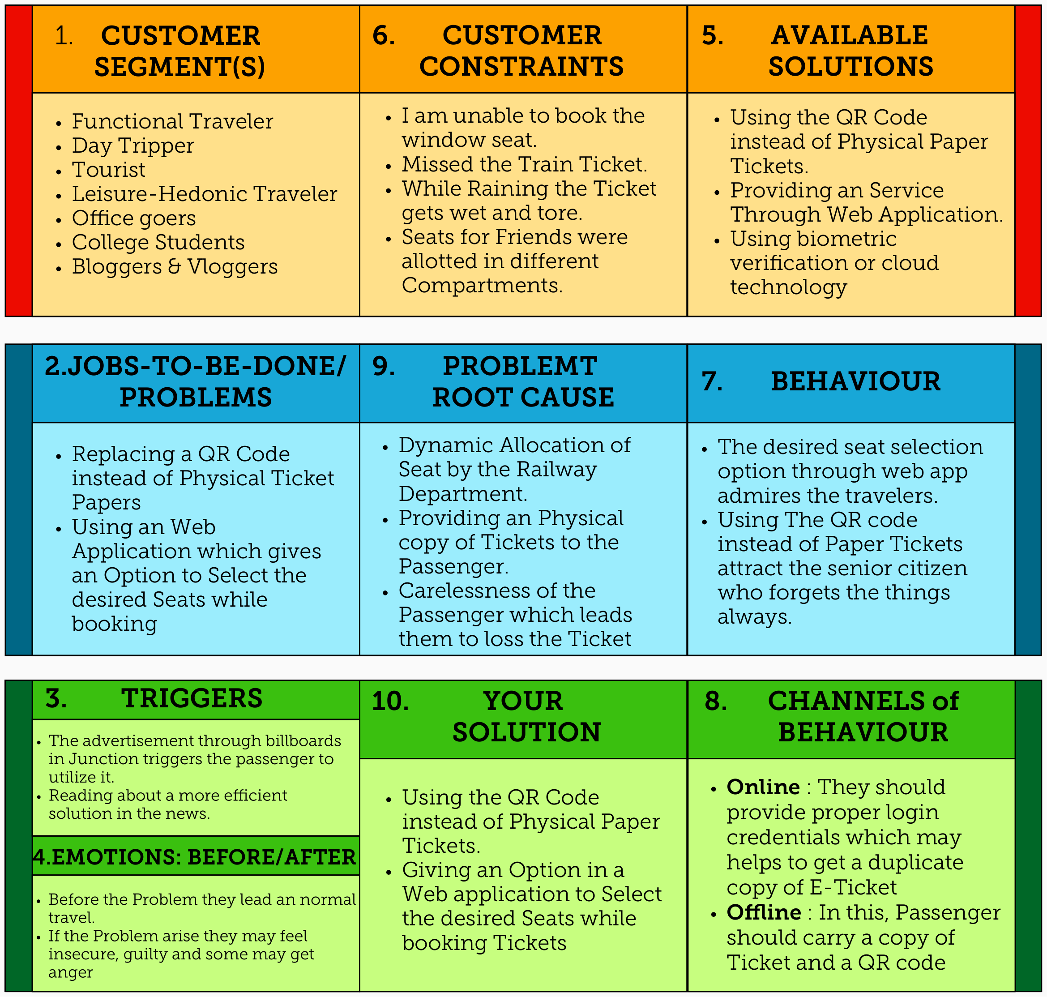

**Focus on J&P, tap into BE, understand RC**

**Explore AS, differentiate**

**Deﬁne CS, ﬁt into CC**